Senegal Household Enterprise Analysis:
Senegal EHCVM has two waves: 2018 and 2021. Each wave has a section on non-ag household enterprises. This section can give us info on who among the household is the main proprietor, which can be different from the household head. Demographic characteristics such as gender, age, education level etc., can be pulled from the household roster.
In the cleaning section, following variables will be constructed and 5 datasets will be constricted:
- 2018 EHCVM harmonized dataset with household and individual level observations. With dummies for household head, entrepreneur, and whether the household has an enterprise.
- 2021 EHCVM harmonized dataset including both individual and household level observations. With dummies for household head, entrepreneur, and whether the household has an enterprise.
- 2018/2021 merged panel data with a dummy where households are matched across the two waves and another dummy where both households and individuals are matched across the two waves. To match individuals, other than personal ID, some checks will have to be run on gender and age before deciding whether it’s the same person or not. This dataset will also have all the cleaned variables across the two waves. There should be a variable year that can identify year of each wave
- 2018 Individual level indicators from the roster and employment section. Cleaned and properly labelled with the household ID set up in a way that it can be merged with the household level data.
- 2021 Individual level indicators from the roster and employment section. Cleaned and properly labelled with the household ID set up in a way that it can be merged with the household level data.

List of clean variables for the merged dataset are below. All these indicators will be for both years: 2018 and 2021.
- Entrepreneur
  - Age
  - Age as a categorical variable with these categories: 15-29; 30-44; 45-64; 65+
  - Urban/rural (dummy with rural =1)
  - Gender
  - Education level : categorical variable with these categories: less than primary, less than secondary, secondary and higher
  - Type of activity (entrepreneur, wage job, non-wage job, not working)
  - For wage job, create categories for the following:
    - Formal wage job (formal is if they are registered for social security)
    - Public/private employment
    - Number of hours worked in the wage job
    - Sector of job
  - Transition between 2018/2021 -> categorical variable that shows:
    - Not an entrepreneur in either year
    - Entered entrepreneurship in 2021
    - Exited entrepreneurship in 2018
    - Remained an entrepreneur
  - Transition between 2018/2021 -> categorical variable that shows among the entrepreneurs in 2021:
    - Was entrepreneur in 2018
    - Entered from wage job
    - Entered from non-wage job
    - Entered from non-work
  - A dummy variable for those who were entrepreneurs in 2018 and exited entrepreneurship in 2021
  - Dummy variables for each type of problem cited by the enterprise
  - Share of household members who have a wage job
- Household head:
  - Age
  - Gender
  - Education level
  - If the household head is not the entrepreneur:
    - Employment status (employed, unemployed, looking for work)
    - Type of job (wage, non-wage)
    - Sector of employment
- Household level information:
  - Total consumption
  - Welfare quintile based on consumption
  - Household weights
  - Number of enterprises operated by a household
  - Household size
  - Urban/rural
  - Average household consumption
  - Welfare quintile based on consumption
- Household enterprise
  - Total revenues (defined as the sum of revenue from resale of goods; from sale of transformed or manufactured products; from services)
  - Total costs (costs of goods purchased for resale, cost of raw material, operating cost (utilities, rent, supplies, equipment, other services; wages paid to hired workers)
  - Dummy variable for highest revenue generating enterprise within a household
  - Profits (revenues – cost)
  - Log of profit
  - Profits in real terms after cpi adjustment
  - Change in profits
  - Capital value (value of machines, vehicles, furniture, other)
  - Log of capital value
  - Capital value in real terms
  - Change in capital value
  - Access to electricity
  - Total number of employees (family + non-family)
  - Number of family employees
  - Number of non-family employees
  - Change in number of family employees between the two years
  - Change in number of non-family employees between the two years
  - Dummy for whether the enterprise is formal
    - We need two indicators that define formality differently.
      - =1 if has trade registration
      - = 1 if it has an NIF or NINEA
      - =1 if keeps written accounts
  - Sector of operation with these categories: (1/2=1 "Ag and extractives") (3=2 "Manufacturing") (4/5=3 "Utilities and construction") (6/7=5 "Retail") (8=6 "Transport") (17=7 "Personal services") (9/16 18=9 "Other")
  - Year the business was establish
  - Categorical variable for year the business was established with these categories: <2000; 2000-2009; 2010-2014; 2015-2018
  - Place of business, categorical variable with these categories: (i) office, workshop, store, shop, garage; (ii) fixed post on public road; (iii) mobile post on a public road; (iv) at home; (v) client home; (vi) car or motorcycle (vii) walking; (viii) other
  - Agricultural zone
  - Ethnicity
  - Literacy
  - Source of initial funding
  - Age (firm age using categories)
  - Total factor productivity [refer to the do-file titled “Add_gov_measures_and_TFP_estimates.do” to create this variable
  - Value added per worker
  - Value added per worker
  - Categories for number of household member employees: 0, 1, 2+
  - Sources of financing categories
  - Whether the household received any credit
  - Sources of credit (categorical variable)
  - Whether the household received any remittances
Analysis:
Introduction:
- % of households that operate at least 1 enterprise in 2018 & 2021
- Average size of household enterprises (total number of employees, family employees, non-family employees) in 2018 and 2021
Stylized facts on the profile:
- Share of formal HH enterprises using both definitions in 2018 and 2021
- Share of hh enterprises that increased the number of non-family employees working for them between 2018 and 2021
  - Average number of non-family employees in 2018
  - Average number of non-family employees in 2021
  - Number of household enterprises that increased their number of non-family employees between 2018 and 2021
  - Share of household enterprises that increased their number of non-family employees between 2018 and 2021
- Sector of operation (retail/trade, personal services, manufacturing)
  - Share of household enterprises operating in each sector (distribution across sectors)
- Gender of entrepreneurs. Gender of entrepreneurs by sector

Stylized facts on the performance of household enterprises and entrepreneurs
- Average profits of household enterprises in 2018 and 2021
- Percent of Household enterprises that report 0 profits; positive profits; and loss/negative profits in 2018 and 2021
  - The household enterprise section has information on costs and revenues. Profits will be calculated from there
- Variation in profitability over time
  - Average amount of profits in 2018 and 2021 (after making CPI adjustments using data from WDI)
  - Average annual growth rate of profits
  - Share of enterprises with annual growth rate in profits of more than 10%
- Share of enterprises with internet access in 2018 and 2021
- Share of enterprises with electricity in 2021
- Enterprises with internet and electricity access experienced (i) higher profits and (ii) accumulated more capital. For all the regressions, variables are 2021 values if the year is not indicated. These regressions are also in the “regression.do”. If this specification is different from the one in the do-file, use the one in the do-file.
  - For (i), we will run a regression with log profit in 2021 as a dependent variable and the following variables as independent: log of capital value in 2018, log of profit 2018, gender, age categories, location (urban/rural), agricultural zone, ethnicity, literacy (alfab); education categories; internet access; electricity access; per capita consumption; firm age categories, household employee number categories; sector categories with services (5) as base category; place of business categories, categorical variable on self-reported problems with lack of customers (2) as the base category; dummy for firm keeping accounts; dummy for firm having a fiscal id; dummy for firm having trade registration. Use weights. Standard errors clustered at EA level. For each regression, we need marginal effects, standard errors, and whether it is statistically significant. Number of observations and R-squared.
  - For (ii), we will run a regression with log of capital value in 2021 as the dependent variable and the following variables as independent: log of capital value in 2018, log of profit 2018, gender, age categories, location (urban/rural), agricultural zone, ethnicity, literacy (alfab); education categories; internet access; electricity access; per capita consumption; firm age categories, household employee number categories; sector categories with services (5) as base category; place of business categories, categorical variable on self-reported problems with lack of customers (2) as the base category; dummy for firm keeping accounts; dummy for firm having a fiscal id; dummy for firm having trade registration. Use weights. Standard errors clustered at EA level. For each regression, we need marginal effects, standard errors, and whether it is statistically significant. Number of observations and R-squared.
- Formal enterprises also experienced higher growth in terms of number of employees
  - For this, we will be run a regression with non-family employees in 2021 as the dependent variable. Independent variables include: number of non-hh employees in 2018, log of profit, log of capital value, gender, age categories, location (urban/rural), agricultural zone, ethnicity, literacy (alfab); education categories; internet access; electricity access; per capita consumption; firm age categories, household employee number categories; sector categories with services (5) as base category; place of business categories, categorical variable on self-reported problems with lack of customers (2) as the base category; dummy for firm keeping accounts; dummy for firm having a fiscal id; dummy for firm having trade registration. Use weights. Standard errors clustered at EA level. For each regression, we need marginal effects, standard errors, and whether it is statistically significant. Number of observations and R-squared.
- Run all these three regressions with cooperative (legal form) as an additional independent variable (dummy)
Different motives: investment and resilience:
- Variation in endowments and profitability
  - Descriptive stats on level of log capital, log profits and number of non-family employees. Mean, median, 10th percentile, 90th percentile. For each year
  - Variation in profitability and investment (capital value) -> histogram for each
  - Variation in value added per worker (to measure productivity) overall and by sector.
  - Share of household enterprises whose productivity has increased; decreased; or remained the same
- Enterprises that have a growth potential
  - Share of enterprises with at least 1 non-household employee in 2018 and 2021
  - Share and number of enterprises that have increased their number of household employees between 2018 and 2021
  - Share of enterprises with at least 3,000 CFA in capital stock in 2018 and 2021 (after making inflation adjustments)
  - Share of enterprises that increase their capital stock value (after making inflation adjustment) between 2018 and 2021
- Household enterprises and contribution to resilience [placeholder – will do this later]
- Low Entry barriers
  - Share of enterprises that discontinued their operations between 2018-2021.
  - Share of enterprises that set up a new enterprise between 2018-2021
- Household enterprises as stepping stone:
  - Share of enterprises that experienced an increase in profits
  - Share of enterprises that experienced an increase in TFP
  - Share of enterprises that were inactive in 2018
  - Share of enterprises that moved to wage jobs in 2021
- Transition trajectories:
  - If transition was from wage job to enterprise: share of enterprises in 2021, that are now earning more as compared to the wage job; share of enterprises that are earning the same; share of enterprises that are earning less
  - If transition was from enterprise to wage job in 2021: type of job (public/private; formal/informal; sector)
  - For each type of transition: number of hours worked
  - For each type of transition: average number of household members in wage jobs
Recreate these graphs using Senegal’s data:
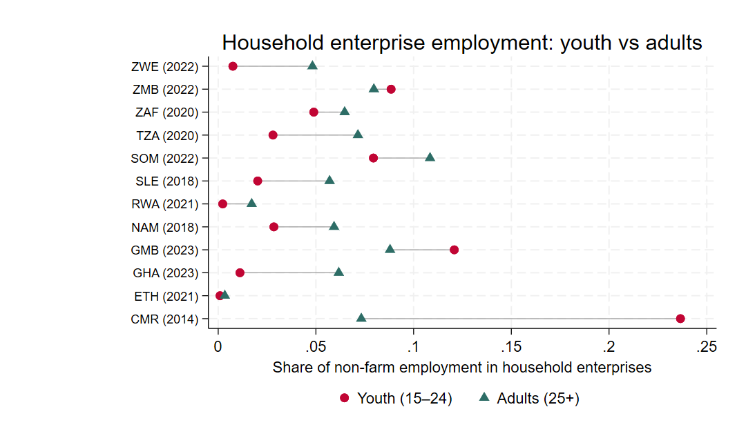
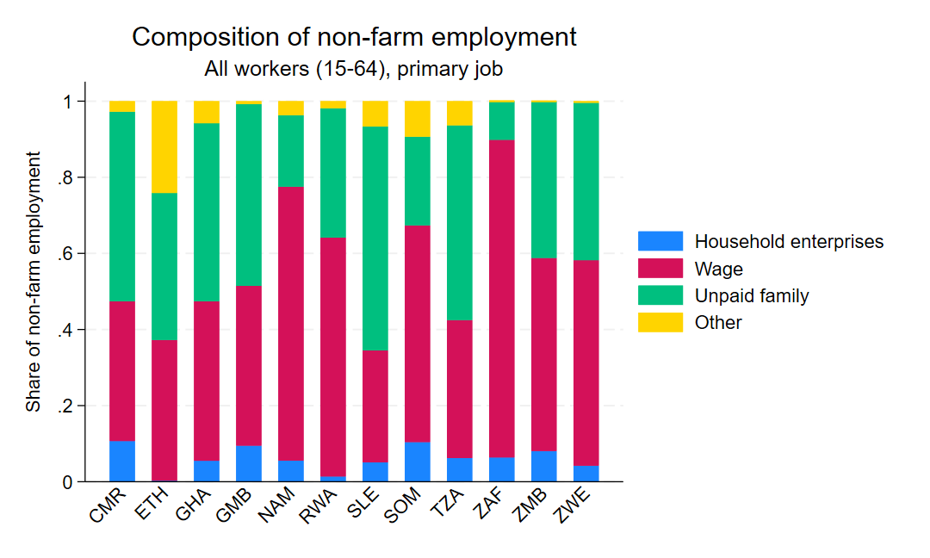
In the graph below, it’s profile of householder entrepreneur vs. wage worker. Use the education categories created above.
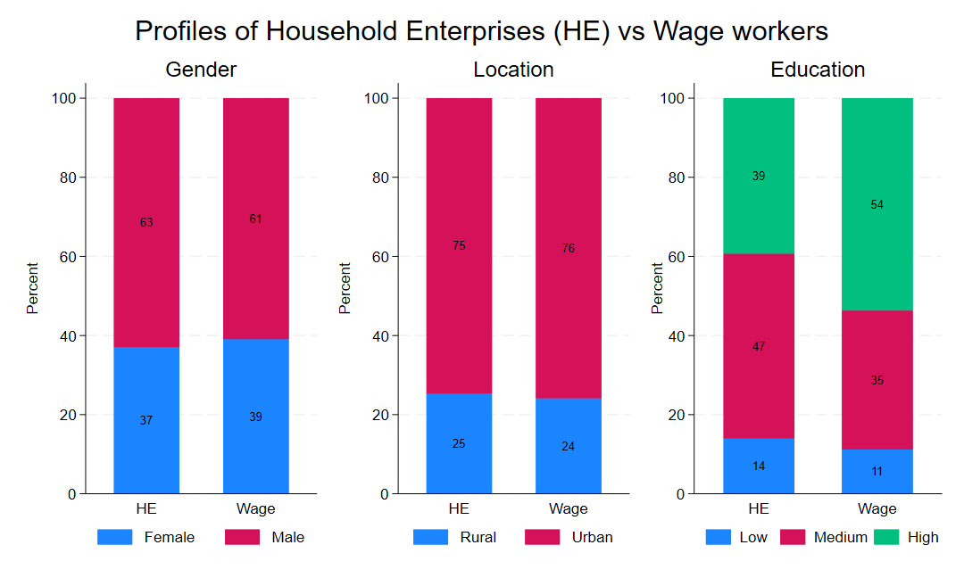
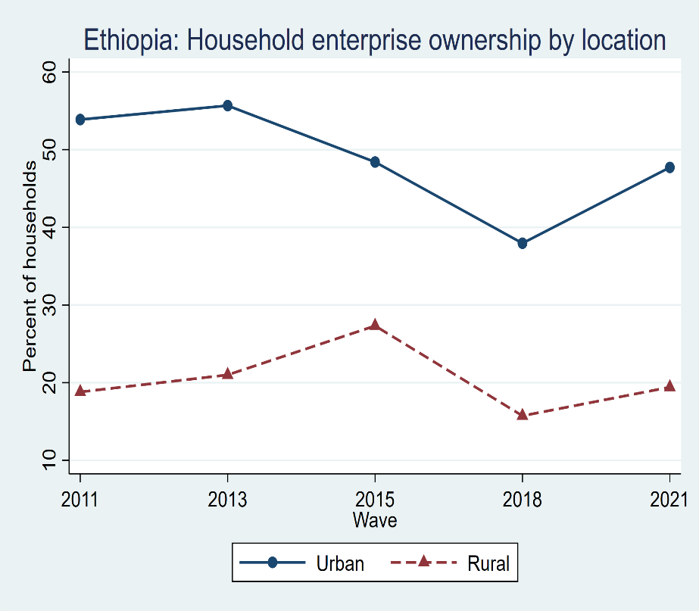
For the graph below, make two versions. One using the categories above and the other with the categories as described in the graph below
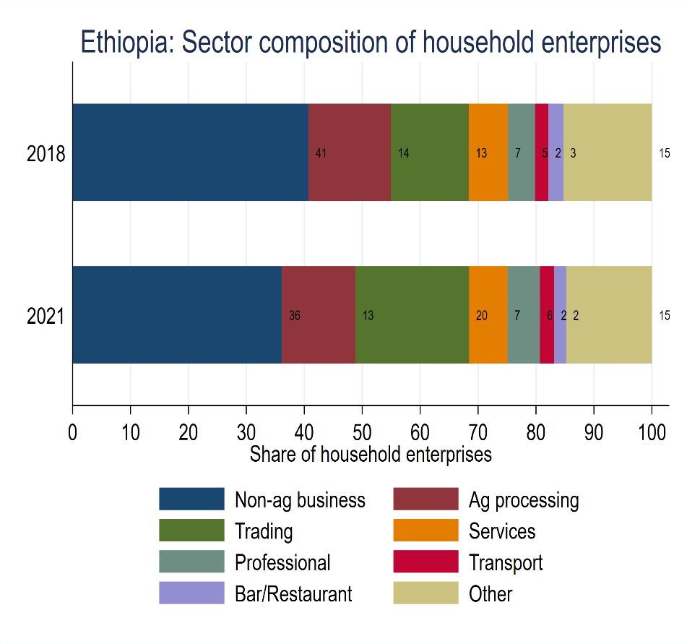
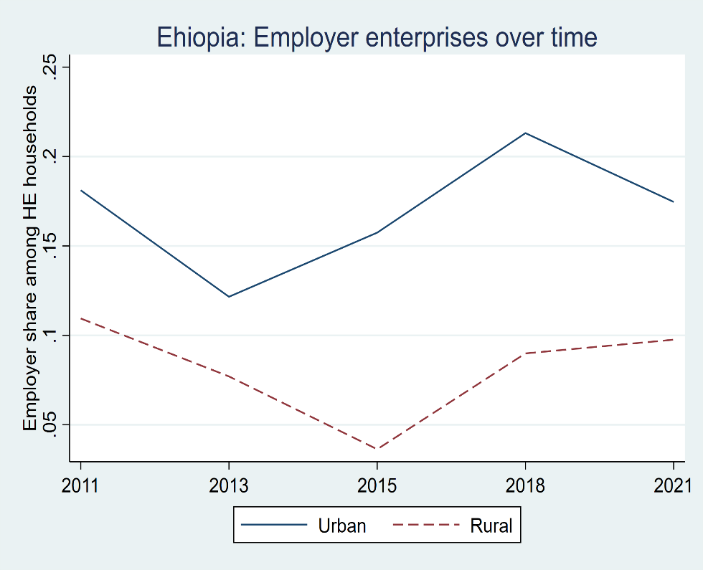
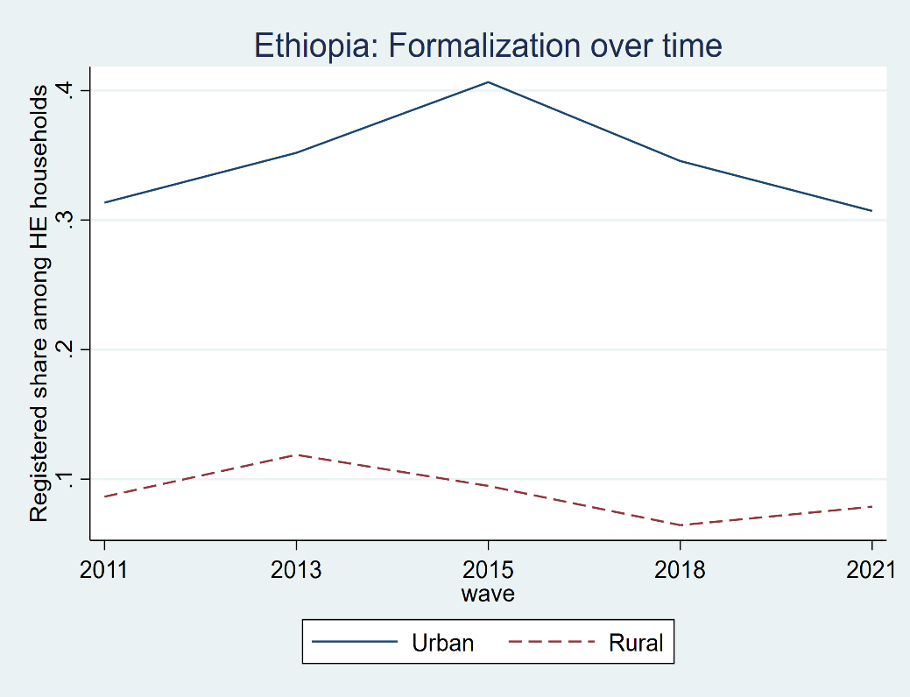
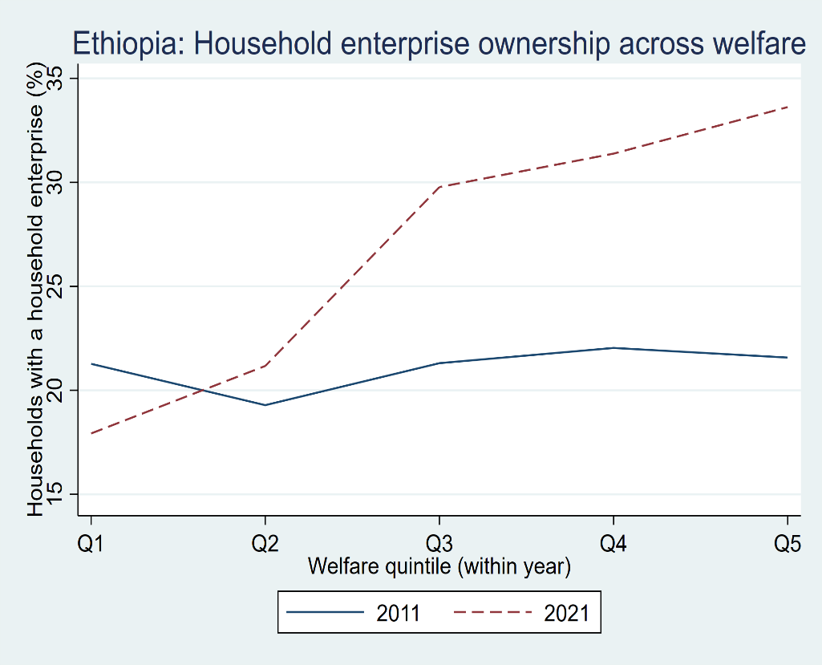
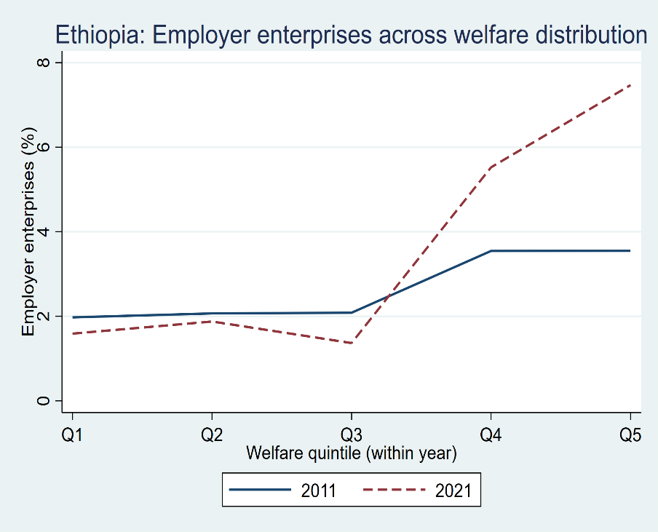
Overall instructions:
- For each household, create a unique ID. This will be a combination of vague grappe menage
- The final dataset should have variables from each year and variable names should clearly differentiate between 2018 and 2021.
- Create a data dictionary in an excel file with the following information:
  - Name of variable and variable label
  - If a variable is being used as is from the questionnaire, use that and also add question number in an additional column
- In the do-files, add clear definitions of key variables as notes
- All the results should be in an excel file in separate tabs.
- Wherever possible use the code from existing do-files
- You can change the type of graph to ensure that key message is conveyed well. Check the color palette before you start making graphs
- I also need the data behind these graphs in the excel sheet. Data for each graph should be in a separate tab. Data should be properly labelled.
- Final outputs are: do files; results in an excel sheet; and dta files with clean data that is being used for the analysis

